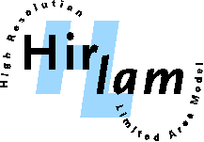



HIRLAM All Staff – ALADIN workshop
23 – 26 April, 2007
CIENS building, Gaustadalleen 21, Oslo

Please fill in this form and submit it by e-mail to:
Jeanette Onvlee (Onvlee@knmi.nl) (for HIRLAM participants) or
Patricia Pottier (patricia.pottier@meteo.fr) (for ALADIN participants)
Application Deadline: 15th March, 2007

PERSONAL DETAILS
Surname

First Name  Male  Female

Institution Department Position

Address

City Phone

Fax Mobile E-mail

ASM/WORKSHOP PARTICIPATION

I would like to participate on the days: 23-26 April / other, namely:
I would like to give a presentation: yes/no
Title of presentation:
I would like to present a poster: yes/no
Title of poster:

Date:

