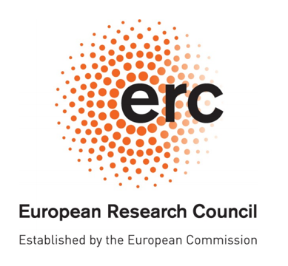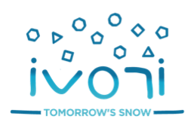

**Postdoctoral position at CNRM-CEN, Grenoble, France**

**Modelling the transport of water vapour in snow**

**General information :**

* Workplace: Centre d’Etudes de la Neige, Grenoble, France
* Contract from ERC Starting Grant project IVORI
* Duration: 24 months
* Expected date of employment: 26 may 2022
* Deadline for application: 30 Mars 2021
* Work proportion: 100%
* Salary will be provided according to Météo-France salary rates and depends on the background of the retained candidate. For example, the growth monthly salary is about 3280€ for 1-2 years research experience after PhD.
* Desired level of education: PhD
* Contact: [marie.dumont@meteo.fr](mailto:marie.dumont@meteo.fr), [pascal.hagenmuller@meteo.fr](mailto:pascal.hagenmuller@meteo.fr), [neige.calonne@meteo.fr](mailto:neige.calonne@meteo.fr)

*Interested in this position? please send CV and motivation letter to the contact persons.*

**Context:**

The position is part of the ERC starting grant project, IVORI, starting in February 2021 (5 years project). IVORI’s goal is to build a microstructure-based snow-firn model encompassing all the relevant snow and firn physical variables to improve the modeling of seasonal and perennial snow. Drawing on advanced observations of snow and firn, the proposal has three objectives:

(1) Understand the role of water vapour transport in snow and its subsequent impacts on the groundthermal regime governing permafrost evolution;

(2) Understand how initial changes in surface snow microstructure are transferred deeper into the firn and affect ice core records;

(3) Determine the contributions of snow-climate feedbacks, triggered by changes in the albedo and insulating capacity of snow to the past and future of snow cover and ground temperature.

**Activities**

The post-doctoral fellow will be in charge of working on the transport equations for water vapor in snow. It might appear necessary to redesign some of the equations starting from the processes at the microscale using homogenization methods. It might also appear necessary to implement convection processes. The work and development will be based on previous and on-going lab experiments at CNRM/CEN. Additional lab experiments can be planned if necessary. Field measurements using X-ray tomography are planned for winter 2021-2022 at Col de Porte (France) and for winter 2022-2023 at the high arctic CHARS station (Canada). The post-doctoral fellow is expected to participate to these field campaigns. The work expected for the post-doctoral fellow has a special focus on water vapor transport in snow and its impact on the soil thermal regime in the Arctic.

The work will be supervised by Marie Dumont, Neige Calonne et Pascal Hagenmuller. The position will take place at CNRM/CEN in Grenoble, France. The position will benefit from the computing facilities of Météo-France including the HPC facilities and also of the X-ray imaging facilities at CEN. It will also benefit from a motivating scientific environment in the context of the research project ERC IVORI about snow microstructure and modelling. Intense collaborations are expected with several laboratories: IGE (Grenoble, France), WSL/SLF (Davos, Switzerland), LJK (Grenoble, France), Aachen University (Germany) and at 3SR (Grenoble, France).

The CNRM is the research center of Météo-France, it is a joint unit of the CNRS. With about 230 permanent staff, its mission is to develop the knowledge and tools that Météo-France needs to produce its forecasts of weather, air quality or climate. One of the six units forming the CNRM, the CEN, focuses on the study of snow. With about 25 permanent staff, CEN has been involved for many years in the snow modelling and observations.

**Keywords**

Snow, microstructure, porous media, homogenization, arctic.

**Skills**

This job requires strong skills in material science, applied mathematics, numerical modeling and X-ray tomography data. A general interest in the cryosphere, experience in snow science and experience in multi-scale modeling of coupled physical processes such as phase change, heat and mass transfer in porous media are assets. Skills for writing documentation, work organization and work independently are also required.